**Experiment No. 6 — Use Sleuth Kit to Analyze Digital Evidence**

**Aim**

To use **The Sleuth Kit (TSK)** command-line tools to analyze a disk image and recover digital evidence.

**Step 1** — install sleuth kit in linux terminal

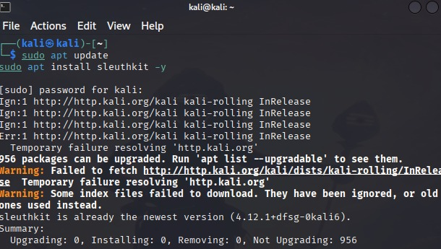

**Step 2** — Create a Dummy Disk Image:

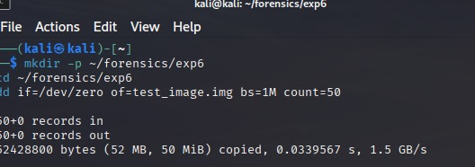

**Step 3** — Format the Image with a Filesystem

**Step 4** — Mount and Add Sample Files

**Step 5** — Identify File System Information & List Files and Directories

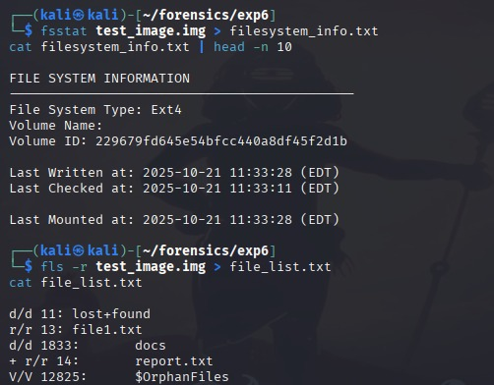

**Step 6** — View Metadata of a File

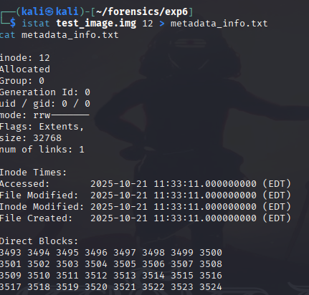

**Step 7** — Recover a File from the Image

**Step 8** — Create a Timeline & Report Generation

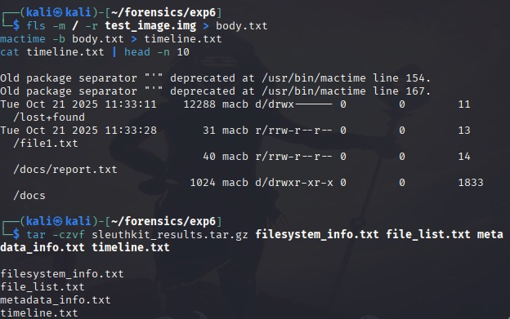

**Result**

Successfully analyzed a disk image using **The Sleuth Kit** tools and extracted file metadata, recovered deleted files, and created a forensic timeline.